**Star Schema Diagram**

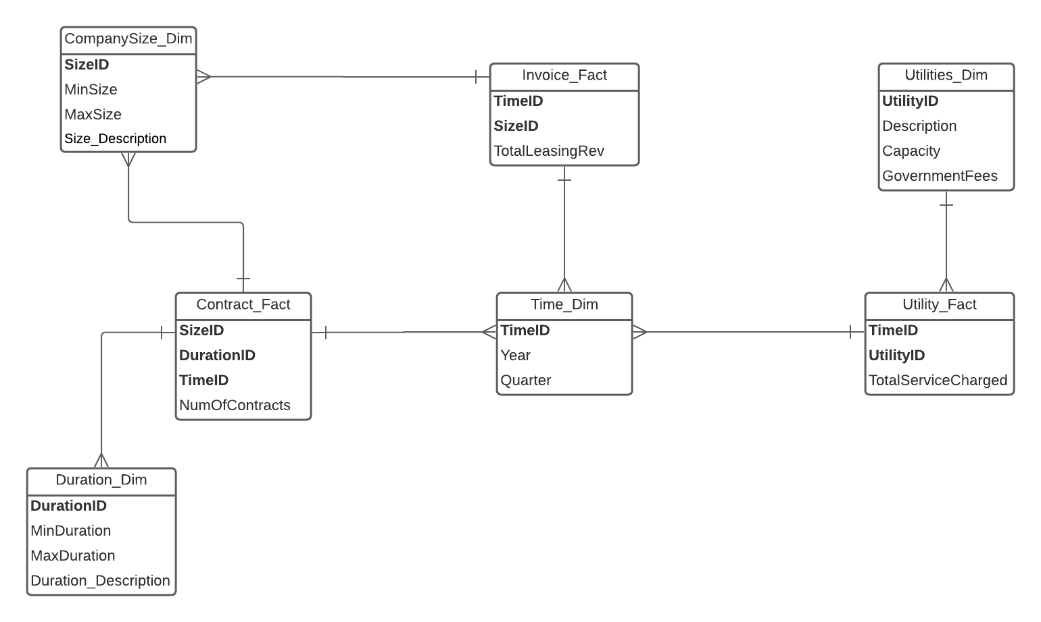

**Two-Column Methodology**

Company Size Dimension

|  |  |  |
| --- | --- | --- |
| SizeID | Number of Contracts | Total Leasing Revenue |
| Small | 6 | 6 |
| Medium | 6 | 6 |
| Large | 6 | 6 |

Duration Dimension

|  |  |
| --- | --- |
| DurationID | Number of Contracts |
| Short-Term | 6 |
| Medium-Term | 6 |
| Long-Term | 6 |

Time Dimension

|  |  |  |  |
| --- | --- | --- | --- |
| TimeID | Number of Contracts | Total Leasing Revenue | Total Service Charged |
| 12016 | 1 | 1 | 1 |
| 22016 | 1 | 1 | 1 |
| 32016 | 1 | 1 | 1 |
| 42016 | 1 | 1 | 1 |
| 12017 | 1 | 1 | 1 |
| 22017 | 1 | 1 | 1 |
| 32017 | 1 | 1 | 1 |
| 42017 | 1 | 1 | 1 |
| 12018 | 1 | 1 | 1 |
| 22018 | 1 | 1 | 1 |
| 32018 | 1 | 1 | 1 |
| 42018 | 1 | 1 | 1 |
| 12019 | 1 | 1 | 1 |
| 22019 | 1 | 1 | 1 |
| 32019 | 1 | 1 | 1 |
| 42019 | 1 | 1 | 1 |
| 12020 | 1 | 1 | 1 |
| 22020 | 1 | 1 | 1 |

Utilities Dimension

|  |  |
| --- | --- |
| UtilityID | Total Service Charged |
| U001 (Water) | 6 |
| U002 (Electricity) | 6 |
| U003 (Waste Collection) | 6 |

**SQL Commands to create Dimension and Fact Table**

--Create Dimensions

DROP TABLE Utility_Dim CASCADE CONSTRAINTS PURGE;

CREATE TABLE Utility_Dim AS SELECT * FROM MRECOMANY.utilities;

DROP TABLE CompanySize_Dim CASCADE CONSTRAINTS PURGE;

CREATE TABLE CompanySize_Dim (

SizeID VARCHAR(15),

MinNoEmployees VARCHAR(15),

MaxNoEmployees VARCHAR(15)

);

INSERT INTO CompanySize_Dim

VALUES('Small',0,20);

INSERT INTO CompanySize_Dim

VALUES('Medium',20,100);

INSERT INTO CompanySize_Dim

VALUES('Large', 100,'Infinity' );

DROP TABLE Duration_Dim CASCADE CONSTRAINTS PURGE;

CREATE TABLE Duration_Dim (

DurationID VARCHAR(15),

MinNoYears VARCHAR(15),

MaxNoYears VARCHAR(15)

);

INSERT INTO Duration_Dim

VALUES('Short-term',0,1);

INSERT INTO Duration_Dim

VALUES('Medium-term',1,5);

INSERT INTO Duration_Dim

VALUES('Long-term', 5,'Infinity');

DROP TABLE Time_Dim CASCADE CONSTRAINTS PURGE;

CREATE TABLE Time_Dim AS SELECT DISTINCT

to_char(inv.InvoiceDate,'QYYYY') as TimeID,

to_char(inv.InvoiceDate,'q') as QuarterID,

to_char(inv.InvoiceDate,'YYYY') as YearID

FROM MREComany.invoice inv;

-- Create Contract Fact

DROP TABLE TempContractFact CASCADE CONSTRAINTS PURGE;

CREATE TABLE TempContractFact AS

SELECT c.clientid,c.contractid, c.ContractSignedDate, c.LeasingStartDate, c.LeasingEndDate, cl.NumberOfEmployees

FROM MREComany.contract c, MREComany.client cl

WHERE c.clientid = cl.clientid

GROUP BY c.clientid,c.contractid,c.ContractSignedDate, c.LeasingStartDate, c.LeasingEndDate, cl.NumberOfEmployees;

ALTER TABLE TempContractFact

ADD (SizeID VARCHAR2(15));

UPDATE TempContractFact

SET SizeID = 'Small'

WHERE NumberOfEmployees <= 20;

UPDATE TempContractFact

SET SizeID = 'Medium'

WHERE NumberOfEmployees > 20

AND NumberOfEmployees <= 100;

UPDATE TempContractFact

SET SizeID = 'Large'

WHERE NumberOfEmployees > 100;

ALTER TABLE TempContractFact

ADD (TimeID VARCHAR2(15));

UPDATE TempContractFact

SET TimeID = to_char(ContractSignedDate,'QYYYY');

ALTER TABLE TempContractFact

ADD (DurationLength VARCHAR(15));

UPDATE TempContractFact

SET DurationLength = to_char(leasingenddate,'YYYY') - to_char(leasingstartdate,'YYYY');

ALTER TABLE TempContractFact

ADD (DurationID VARCHAR(15));

UPDATE TempContractFact

SET DurationID = 'Short-Term'

WHERE DurationLength < 1;

UPDATE TempContractFact

SET DurationID = 'Medium-Term'

WHERE DurationLength >= 1

AND DurationLength <= 5;

UPDATE TempContractFact

SET DurationID = 'Long-Term'

WHERE DurationLength > 5;

DROP TABLE ContractFact CASCADE CONSTRAINTS PURGE;

CREATE TABLE ContractFact AS

SELECT SizeID, DurationID, TimeID, count(contractid) as NumOfContracts

FROM TempContractFact

GROUP BY SizeID, DurationID, TimeID;

--Create Invoice Fact

DROP TABLE TempInvoiceFact CASCADE CONSTRAINTS PURGE;

CREATE TABLE TempInvoiceFact AS

SELECT inv.totalprice,inv.invoicedate,cl.numberofemployees

FROM MREComany.invoice inv, MREComany.client cl

WHERE inv.clientid = cl.clientid

GROUP BY inv.invoiceid,cl.clientid, inv.totalprice,inv.invoicedate,cl.numberofemployees;

ALTER TABLE TempInvoiceFact

ADD (SizeID VARCHAR2(15));

UPDATE TempInvoiceFact

SET SizeID = 'Small'

WHERE NumberOfEmployees <= 20;

UPDATE TempInvoiceFact

SET SizeID = 'Medium'

WHERE NumberOfEmployees > 20

AND NumberOfEmployees <= 100;

UPDATE TempInvoiceFact

SET SizeID = 'Large'

WHERE NumberOfEmployees > 100;

ALTER TABLE TempInvoiceFact

ADD (TimeID VARCHAR2(15));

UPDATE TempInvoiceFact

SET TimeID = to_char(invoicedate,'QYYYY');

DROP TABLE InvoiceFact CASCADE CONSTRAINTS PURGE;

CREATE TABLE InvoiceFact AS

SELECT SizeID, TimeID, sum(TotalPrice) as TotalLeasingRevenue

FROM TempInvoiceFact

GROUP BY SizeID, TimeID;

-- Create Utility Fact

DROP TABLE TempUtilityFact CASCADE CONSTRAINTS PURGE;

CREATE TABLE TempUtilityFact AS

SELECT u.utilitiesid,u.description, uu.consumptionenddate, uu.totalprice

FROM MREComany.utilities u, MREComany.utilities_used uu

WHERE u.utilitiesid = uu.utilitiesid

GROUP BY u.utilitiesid,u.description, uu.consumptionenddate, uu.totalprice;

ALTER TABLE TempUtilityFact

ADD (TimeID VARCHAR2(15));

UPDATE TempUtilityFact

SET TimeID = to_char(consumptionenddate,'QYYYY');

DROP TABLE UtilityFact CASCADE CONSTRAINTS PURGE;

CREATE TABLE UtilityFact AS

SELECT UtilitiesID,TimeID, sum(TotalPrice) as TotalServiceCharged

FROM TempUtilityFact

GROUP BY UtilitiesID, TimeID;

**Query Results**

-- 1

SELECT SizeID, sum(TotalLeasingRevenue) as TotalLeasingRevenue

FROM InvoiceFact

WHERE substr(TimeID,2,5) = '2019'

GROUP BY SizeID;

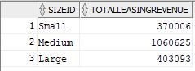

-- 2

SELECT TimeID,UtilitiesID,sum(TotalServiceCharged) as TotalServiceCharged

FROM UtilityFact

WHERE UtilitiesID = 'U001'

AND TimeID = '12016'

GROUP BY UtilitiesID,TimeID;



-- 3

SELECT DurationID,sum(NumOfContracts) as NumOfContracts

FROM ContractFact

WHERE SizeID = 'Large'

GROUP BY DurationID;

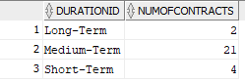

-- 4

SELECT SizeID, substr(TimeID,2,5) as Year ,sum(NumOfContracts) as NumOfContracts

FROM ContractFact

GROUP BY SizeID,substr(TimeID,2,5)

ORDER BY NumOfContracts DESC;

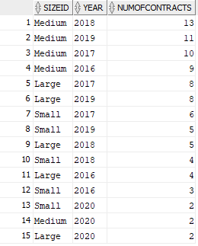

**Appendix**

Size Dimension

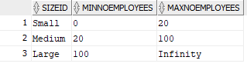

Duration Dimension

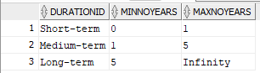

Time Dimension

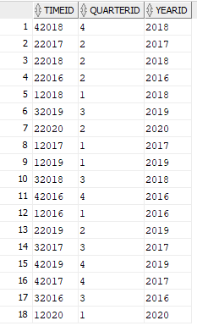

Utility Dimension

